### **Practice Simulation of Blinking LED and Traffic Light on ESP32 using Wokwi**

*Candra Wahyu Perdana*

Vocational Faculty, Brawijaya University

Email: candraega28@gmail.com

**Abstract**

This experiment aims to analyze the implementation of LED blinking and a traffic light system using ESP32 on the Wokwi simulator. The system consists of LEDs connected to GPIO pins to simulate a traffic light with red, yellow, and green LEDs operating in sequence. The results indicate that the LEDs should function in a predefined cycle to simulate traffic control. The experiment highlights the importance of correctly configuring GPIO pins and verifying circuit connections.

*Keywords—Internet of Things, WiFi Scanning, ESP32, Wireless Network*

**1. Introduction**

**1.1 Background**

The Internet of Things (IoT) is growing rapidly in various fields, especially in automation and electronic device control. One of the main components in IoT is microcontrollers like ESP32, which can be programmed to control various devices, including LEDs. This practicum aims to understand the basics of ESP32 programming through simulation using the Wokwi platform. Additionally, a traffic light system will be implemented to simulate real-world traffic control operations.

**1.2 Objectives**

* Understand how the ESP32 microcontroller operates in controlling output devices.
* Implement a traffic light system using ESP32.
* Identify potential issues in the simulation and how to resolve them.

**2. Methodology**

**2.1 Tools & Materials**

* **Hardware:** ESP32 (simulated in Wokwi), Red LED, Yellow LED, Green LED, 220Ω Resistors, jumper wires
* **Software:** Wokwi Simulator, Arduino IDE

**2.2 Implementation Steps**

1. Create a new project in Wokwi.
2. Add ESP32 and three LEDs (Red, Yellow, Green) to the circuit diagram.
3. Establish connections by linking the LEDs to GPIO 25 (Red), GPIO 26 (Yellow), and GPIO 27 (Green) through 220Ω resistors.
4. Write and upload the following code to Wokwi

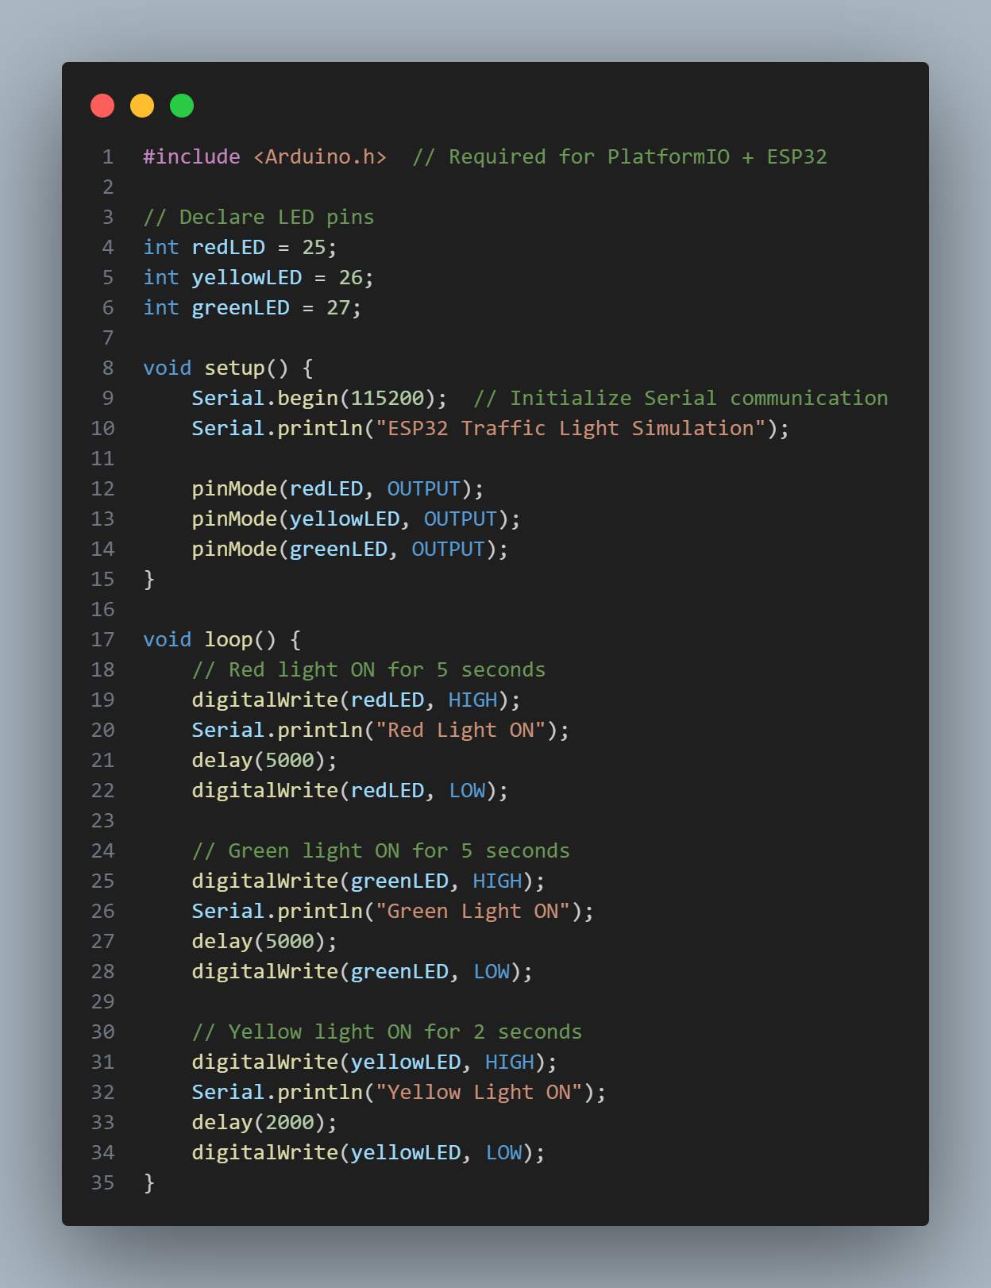

**3. Results and Discussion**

**3.1 Experimental Results**

The simulation successfully implemented a traffic light system with LEDs switching on and off in the correct sequence. Observations:

* The **red LED** lights up for 5 seconds, representing the stop signal.
* The **green LED** lights up for 5 seconds, representing the go signal.
* The **yellow LED** lights up for 2 seconds, indicating a transition between red and green lights.

Possible issues encountered and solutions:

* **Incorrect wiring:** Ensuring the LEDs are correctly connected to the ESP32 GPIO pins and ground.
* **Timing adjustments:** Delays can be fine-tuned to match real traffic light sequences.
* **Simulation bugs:** Restarting the Wokwi simulator if errors occur.

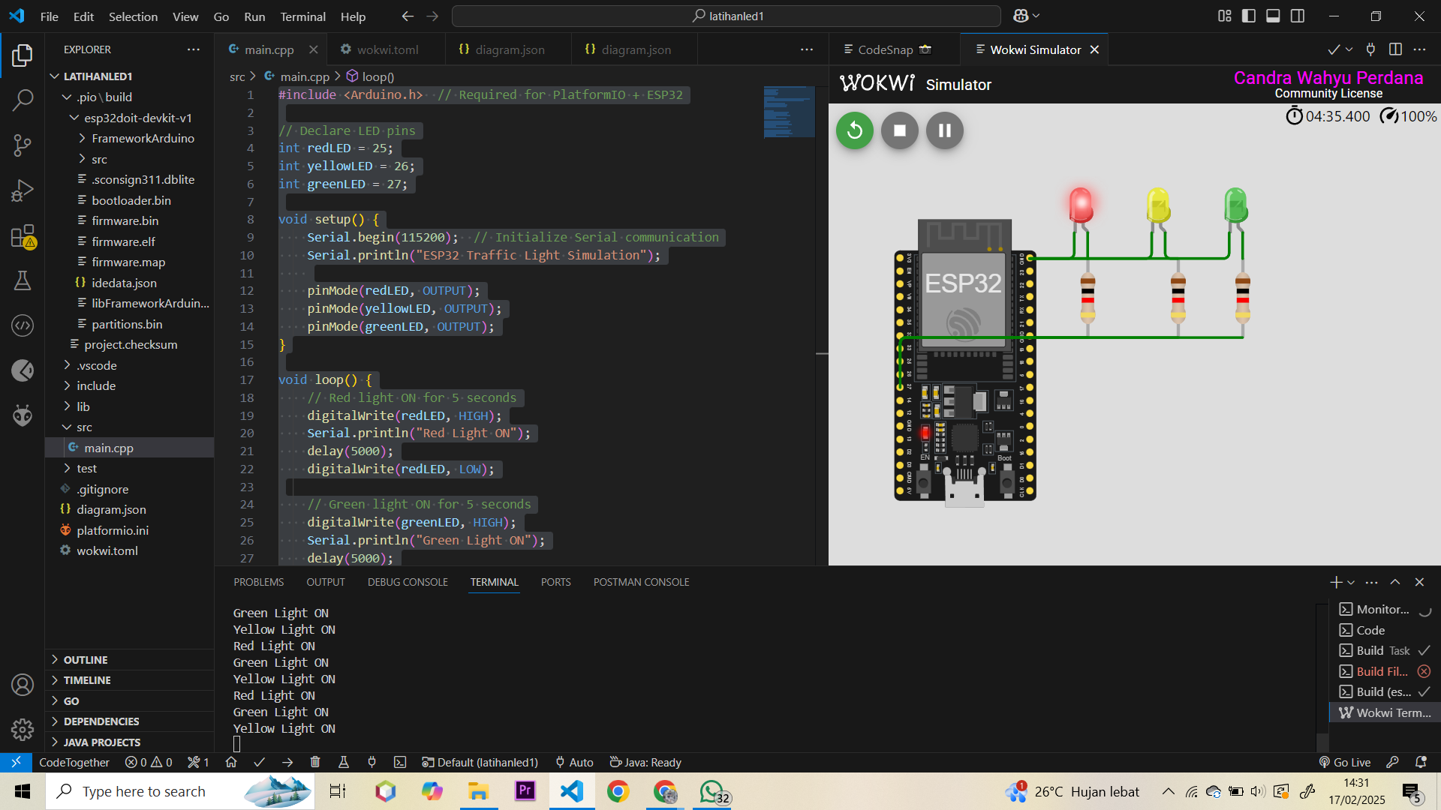

**4. Appendix**

#include <Arduino.h> // Required for PlatformIO + ESP32

// Declare LED pins

int redLED = 25;

int yellowLED = 26;

int greenLED = 27;

void setup() {

Serial.begin(115200); // Initialize Serial communication

Serial.println("ESP32 Traffic Light Simulation");

pinMode(redLED, OUTPUT);

pinMode(yellowLED, OUTPUT);

pinMode(greenLED, OUTPUT);

}

void loop() {

// Red light ON for 5 seconds

digitalWrite(redLED, HIGH);

Serial.println("Red Light ON");

delay(5000);

digitalWrite(redLED, LOW);

// Green light ON for 5 seconds

digitalWrite(greenLED, HIGH);

Serial.println("Green Light ON");

delay(5000);

digitalWrite(greenLED, LOW);

// Yellow light ON for 2 seconds

digitalWrite(yellowLED, HIGH);

Serial.println("Yellow Light ON");

delay(2000);

digitalWrite(yellowLED, LOW);

}